# Kin station mean in different cell type groups – (Diatom, Flagellate, Pico)

Flagellate showed less errorbar, but different cell type of groups didn’t show clear values on kin

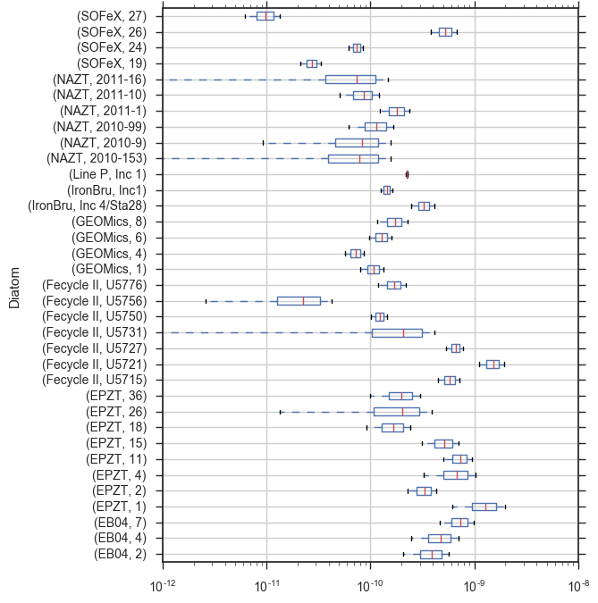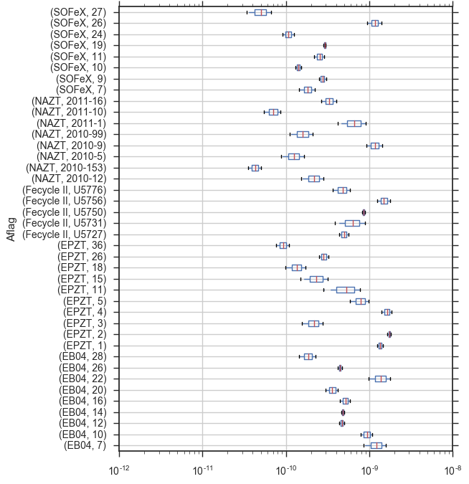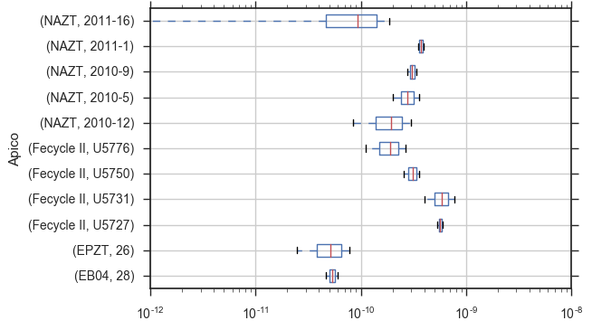

# Relationship between 2 parameters within different groups

Honestly, I didn’t some clear trend in those eco-parameters.

